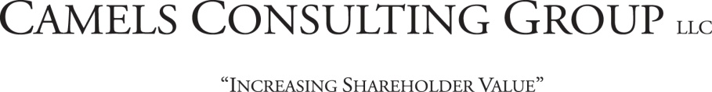
Guidance
for
Recording Stock Ownership

Requirement: Stock Holder Accounting System.

Overview:

Privately held stock is often held in certificate form and managed with a ledger system or an Excel spread sheet environment. More recently banks have moved to book entry form based on availability and reduced cost of more sophisticated accounting systems coupled with shareholder demands.

Current shareholder accounting systems accommodate both certificate and book entry simultaneously. To properly manage a SDIRA program a shareholder accounting system is essential. CAMELS recommends ownership identified in ‘book entry’ form.

(SDIRA ownership held in certificate form requires additional bank controls and procedures. Banks must address adequate process ensuring audit and operational dual controls and safe keeping of certificates. CAMELS does not recommend printing of ownership certificate due to needed audit controls, dual custody processes, as being fundamentally unnecessary and costly.)

Book entry of SDIRA ownership is maintained on the books of the bank and mirrors that of brokerage firm account documentation. Account holders would receive at minimum annualized ledger statements of ownership (elective to increase frequency of statements to quarterly … driving continual contributions.)

CAMELS recommends the following Shareholder Accounting Systems sources:
- One firm is recommended for the Shareholder Accounting function. This firm is offered to those banks that utilize a manual ledger system, excel spread sheets, or other system determined to be unable to handle necessary record keeping.
  - Cambridge Technologies, Inc./Shareholder Accounting systems; (www.cambridge-tech.com); Tel: 618-594-3274; 951 Fairfax Street, Carlyle, IL 62231

